**FET Centre, Kilmallock**

**Amber Flag Initiative- Positive Well- Being**

As part of the Amber Flag Initiative, which promotes positive mental health, The FET Centre, Kilmallock held a Positive Well Being Day on Wednesday, May 18, 2016. The PLC, VTOS and ALS groups within the College organised a day that was made up of various workshops to help promote positive well-being and positive mental health.

Workshops began at 10am – this included cards, darts, flower arranging, nails, horticulture - students got involved in one of the five workshops and were able to take away completed arrangements or learn how to manicure from a former beauty therapist. Cards and darts were a great way for the men to get involved and compete in a healthy way. Tony Ryan (VTOS) won one round while we do understand that Peter Lynch (VTOS) won all the other rounds!!!

Mary Forde, from the Kilmallock Mental Health Services, presented to the group on depression, the signs, symptoms, and how to manage it. All students and staff attended this presentation and found it very beneficial as all were able to relate to her message and bring away key points.

The day continued with De-stressing Techniques workshop hosted by Pranic Healing or the Basics of Drawing by Mary Barry Fitzgerald. Both of these workshops were very beneficial and allowed the groups to learn various ways to de-stress either through art or meditation.

The day was brought to a close as the groups gathered for lunch in the Campus Canteen. It was a “bring and share” event where everyone savoured a homemade treat.

The Amber Flag Committee would like to thank all the members involved, the students for attending and the volunteers that helped make the day at The FET Centre, Kilmallock a memorable one.

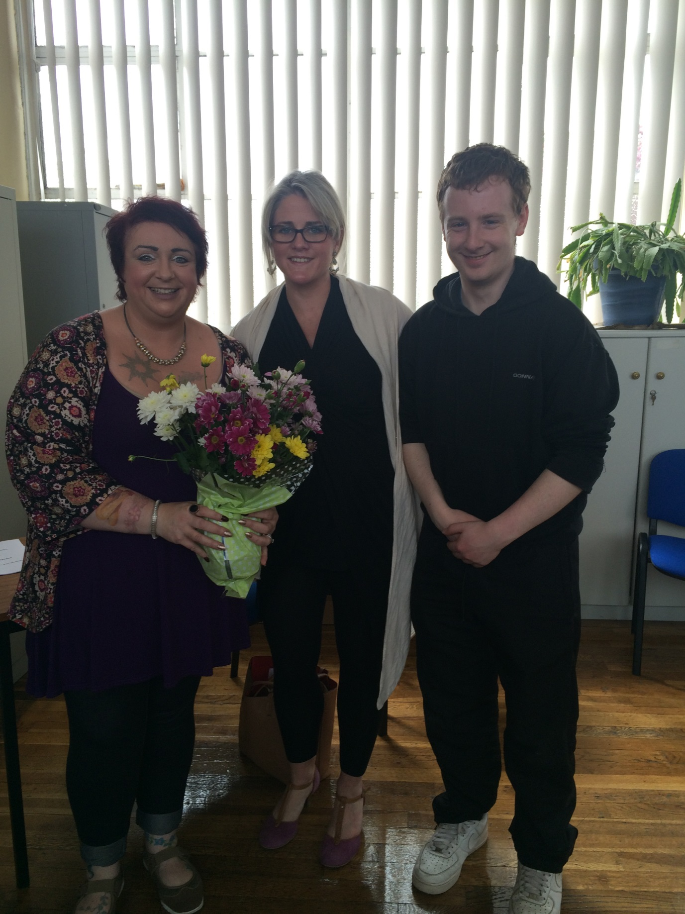

Teresa Mortell (VTOS), Mary Forde (Kilmallock Mental Health Services), Peter Lynch (VTOS).

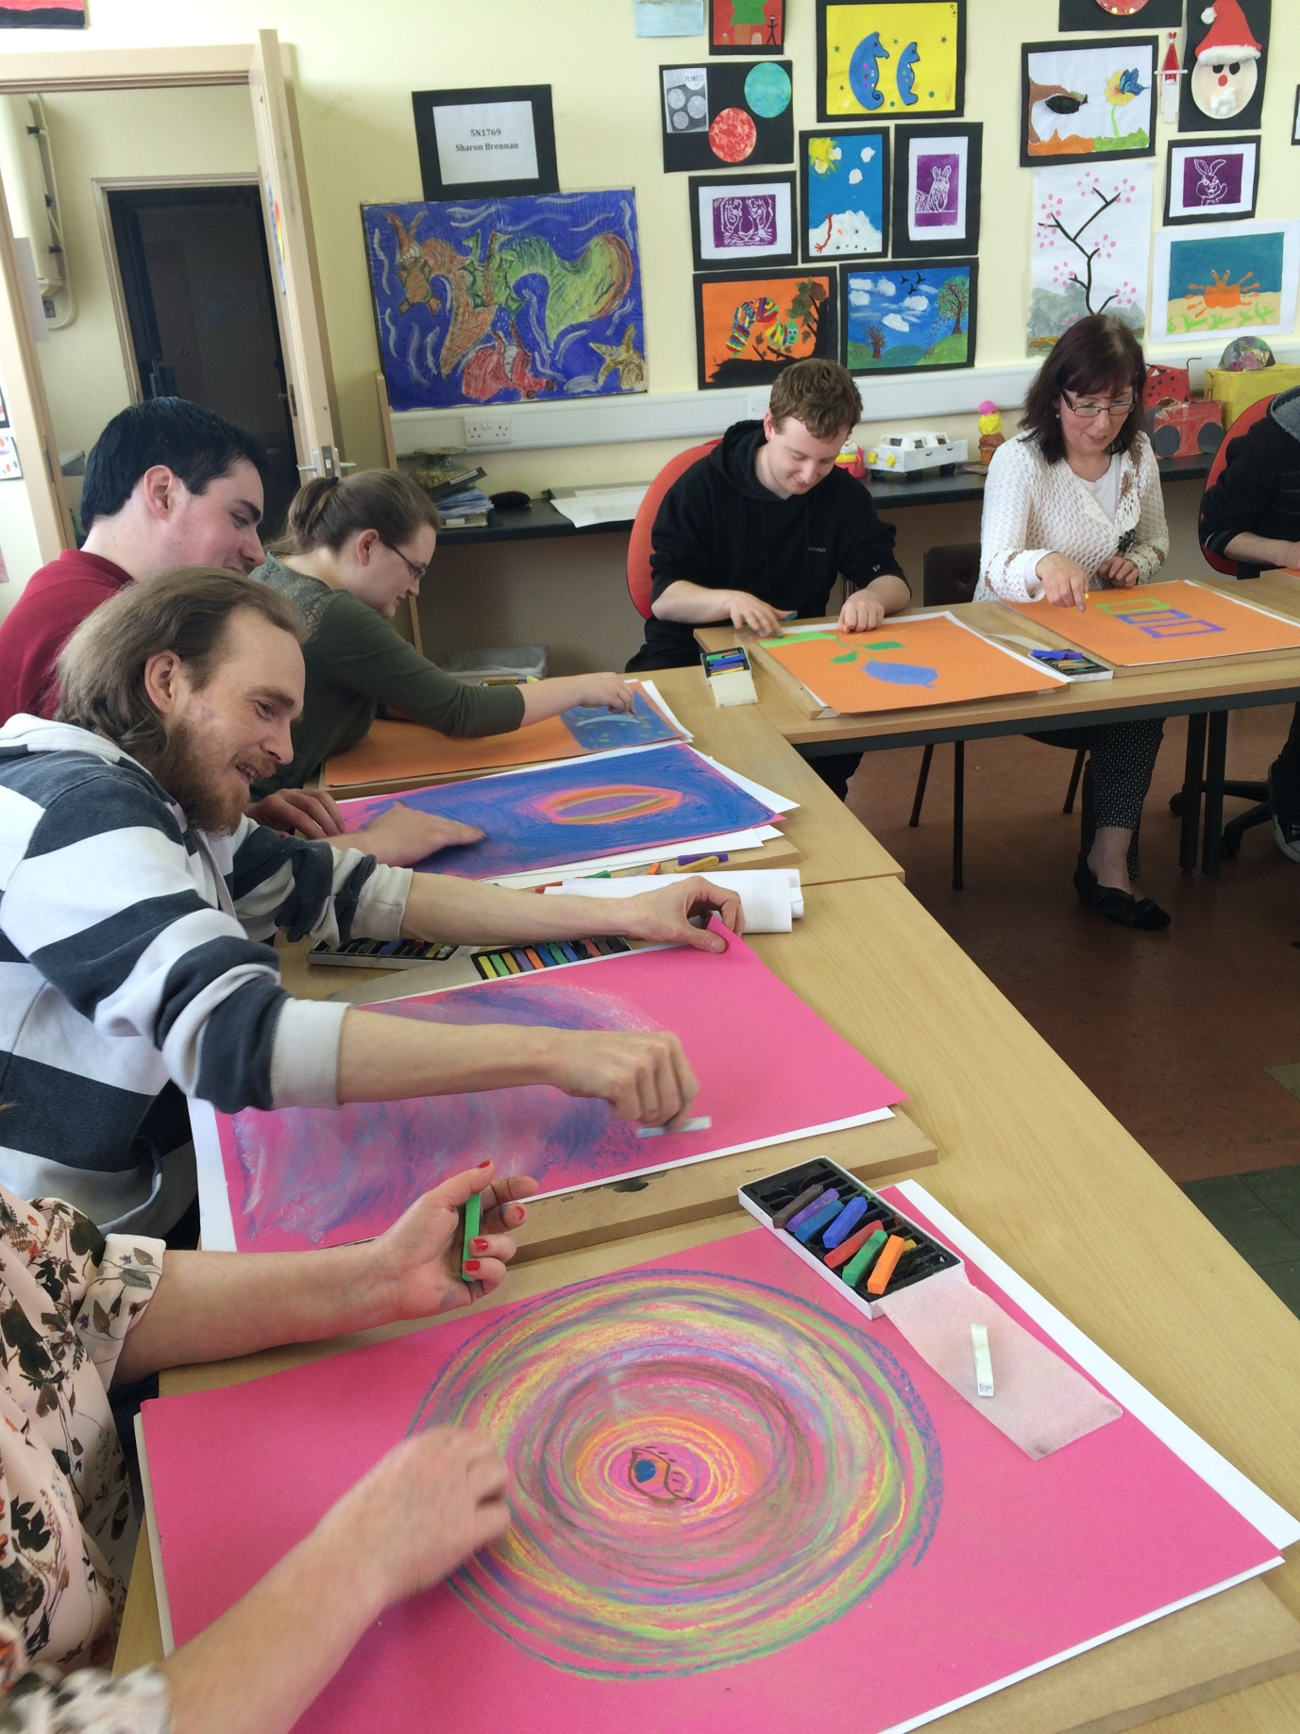

A group of PLC and VTOS learners and staff attending the Drawing Workshop

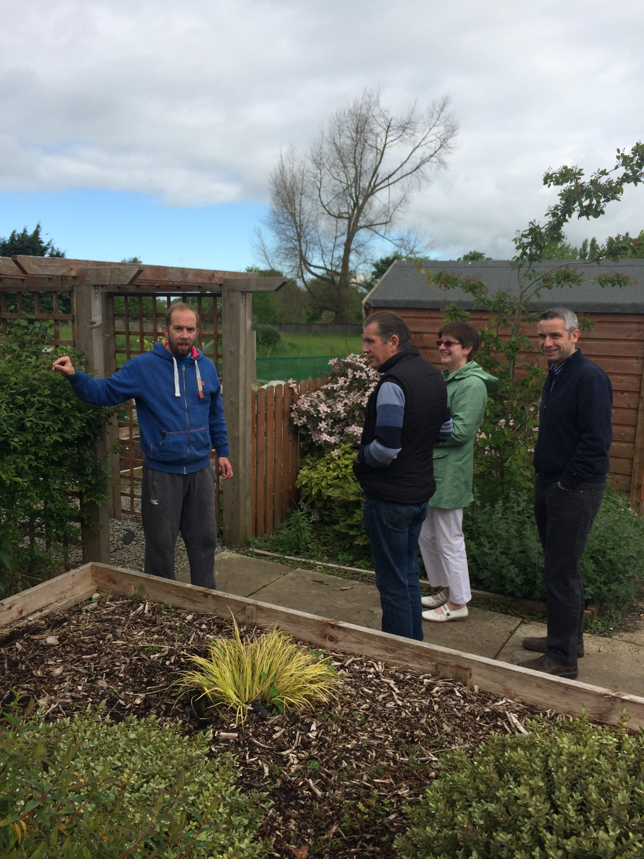

Mike Garry presenting the horticulture workshop to PLC, VTOS staff and learners.

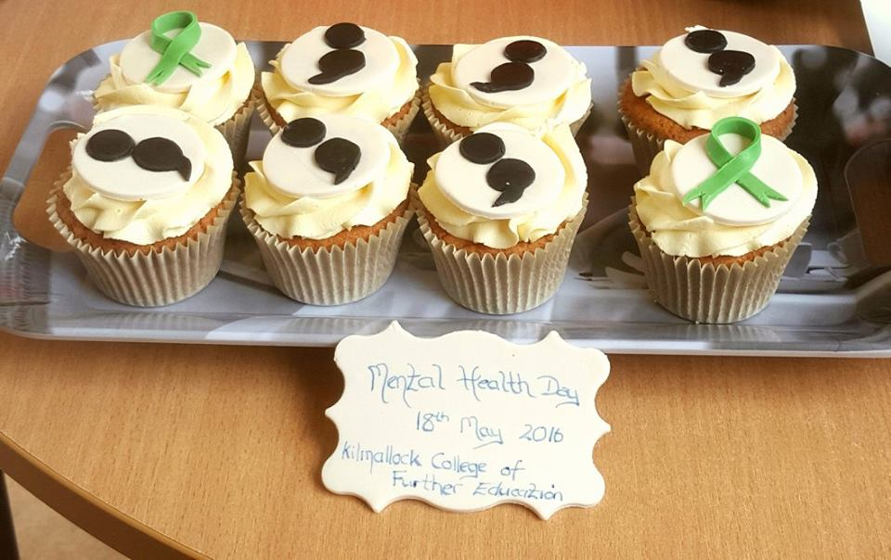

Cup cakes made by Sara Cleary for the amber flag day.

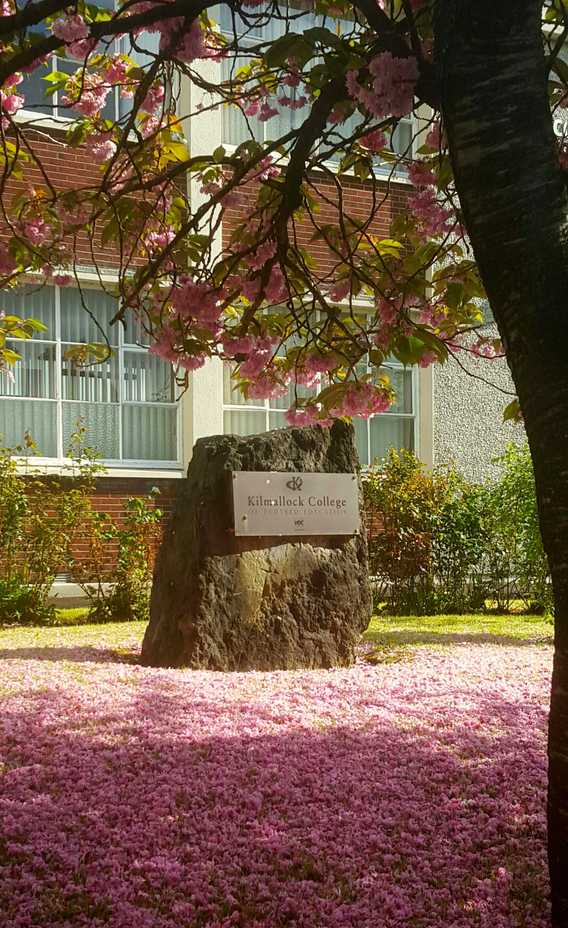

Mid-May at Kilmallock College of Further Education

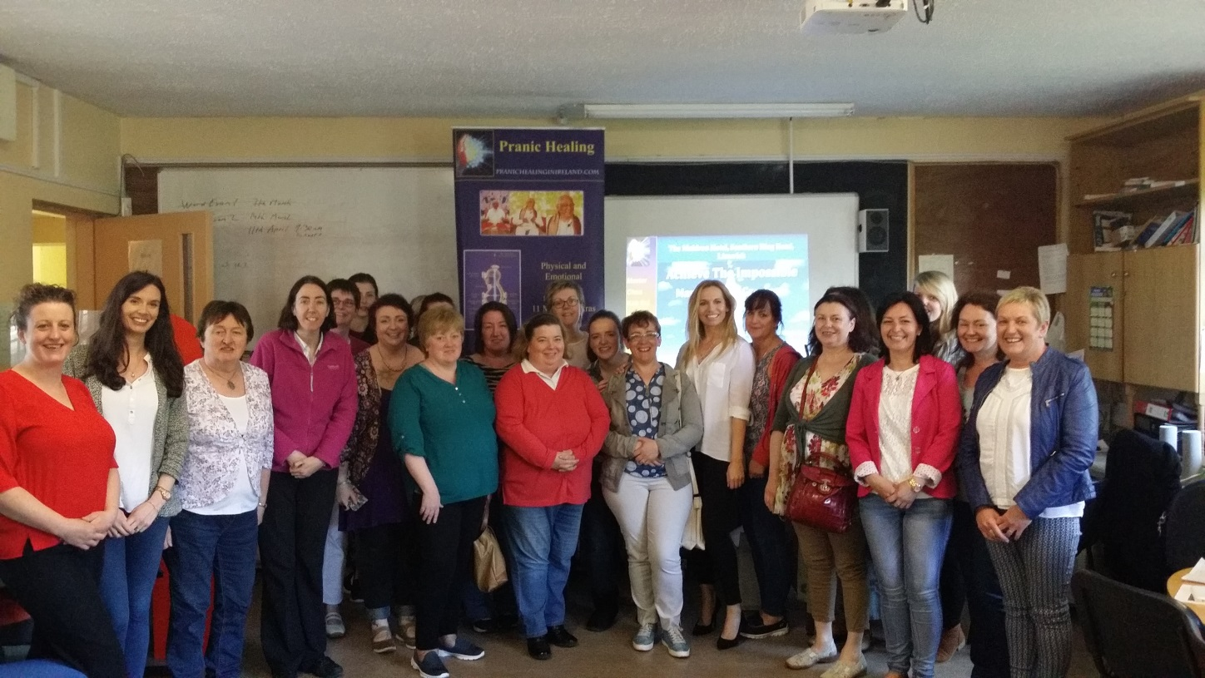

Some of the PLC and VTOS staff and students at the Pranic Healing Workshop.